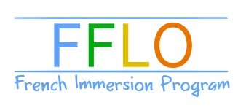
Registration Form Toddler Class

Child's name: First Last
Birth date:

Parents name:

Address:

Zip Code:

City:

Phone number:

E-mail:

Date: Signature:

Note: Families with more than one child enrolled qualify for a 10% discount of the total due.
Please make check payable to Magda Lahliti.
Cost is $25/ class. Drop in is $28 Full Session is $300

FFLO POLICIES

By registering to this class you agree to the following enrollment policies. The payment must be given at the first day of class.

REFUNDS

The tuition is refundable based on the following schedule:
After the first week __75% refund
After the second week __50%
After the third week of classes_ no refund
In addition, a 100% refund policy applies to any classes that are cancelled due to underenrollment.

Payment accepted : Cash, Check made to Magda Lahliti or Venmo.

